The POLYBLOCK building system
Introduction
The Polyblock system is known generically as either ICFs (Insulated Concrete Forms) or LCFs (Lightweight Concrete Forms).
LCF/ICF systems have been used for over 30 years in countries where thermal insulation and energy efficiency are key requirements. The systems are compliant with the new ‘green’ , eco friendly building codes.
The system is in essence a hollow expanded polystyrene block that acts as formwork for a reinforced concrete infill and stays in place to thermally insulate the building.
The system is completed by plastering with a special expanded polystyrene plaster: Polyplast or (internally only) by lining the walls with gypsum board.
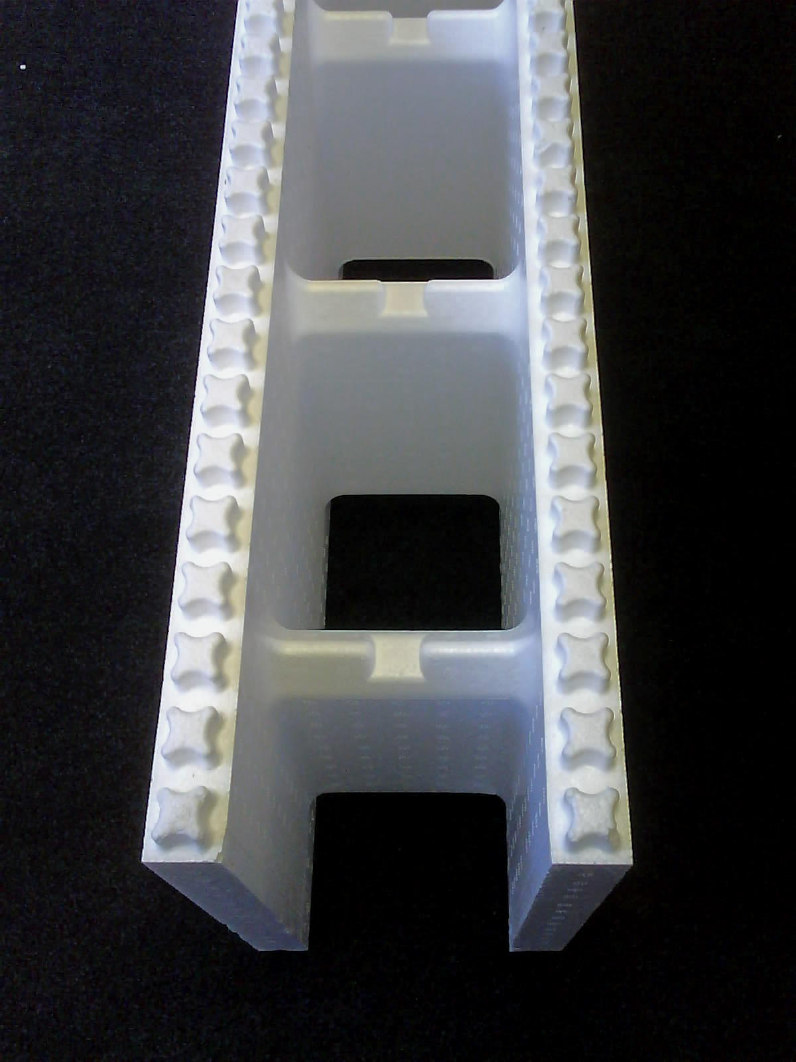
180mm POLYBLOCK
Advantages of building with Polyblock
- Thermal insulation significantly better than brick and block construction including cavity walls. This gives better living conditions, building comfort and allows reduction in energy costs. Thermal insulation(R value) of a Polyblock wall is rated at 1,76 which is 4 to 5 times better than a conventional cavity brick wall and 10-12 times better than a single skin brick wall.
2.
- Wall strength 2,5 times higher than an equivalent brick wall. The concrete strength used as the Polyblock infill is 15MPa vs. normal brick/mortar strength of 7 MPa.
- Ease of building. Can train unskilled workers to use the system quickly. There is minimal requirement for skilled artisans.
- Speed of construction. Walls can be built up to 5 times faster than normal clay/cement bricks. Depending on the complexity of the building 30-60m² of Polyblock wall can be constructed per day compared to 10m² of brick with the same size work crew.
- Services can be installed easily. Plumbing and electrical services can be run through the hollow core before concrete filling or easily cut into the polystyrene surface without angle grinding or chiseling
- Walls are 50% lighter than equivalent sized brick walls allowing reduction in structural support systems
- Lower maintenance costs as the structure is a monolithic reinforced concrete wall in permanent expanded polystyrene formwork. The reinforcing configuration ties the system together preventing cracks in the walls. The expanded polystyrene Polyblocks insulate the wall and thus prevents excessive wall movement due to temperature change that can lead to cracking.
- Expanded polystyrene is impervious to water giving much improved resistance to water and damp penetration
- The Polyblock system is Agremént certified (Agrément number 2007/336) and NHBRC approved. This eliminates risk in building with the system and facilitates project finance
- Costs of building are reduced due to the speed and use of unskilled labour. Building occupancy can be achieved earlier.
Expanded polystyrene building systems such as Polyblock, have been used for over 35 years elsewhere in the world and are standard all over the world primarily due to their thermal insulation properties.
Application Areas
Polyblock should be considered as the building system of choice if any of the following conditions exist:
- Lack of skilled artisans
- Unstable ground conditions
- In areas with high rainfall or excessive damp
- Sites with logistical supply problems where bricks are difficult to obtain or to transport to site
- Speed of delivery and early occupancy are critical
- Wall weight is an issue
- There are extremes of temperature
Project and building types that lend themselves to Polyblock include:
- Phased residential developments; cluster housing and simplex and duplex apartments
- Mine housing
- Schools and clinics
- High rise building conversions from commercial to residential
- Steel frame industrial buildings
- Perimeter, security and retaining walls
3.
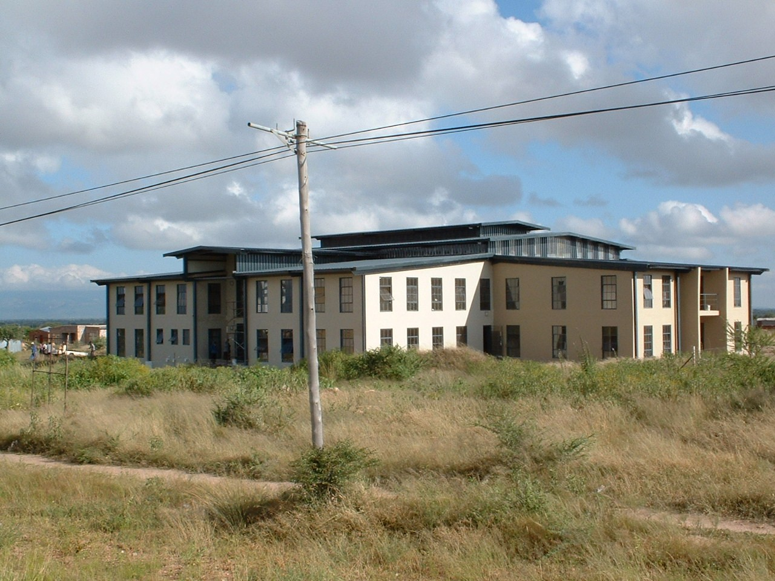
1800m² Limpopo Polyblock Educational Centre
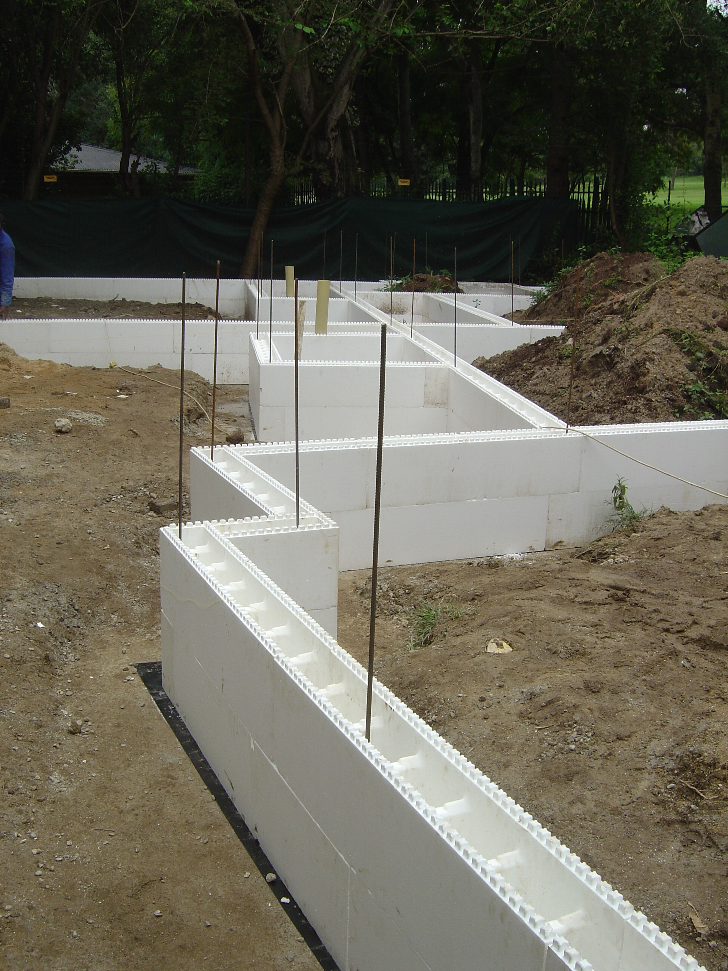
Polyblock house under consruction
POLYBLOCK –BUILDING COMFORT BY DESIGN
www.abpbuildingproducts.co.za

